**USER GUIDE**

**LAB AUTOMATION**

**FACULTY NAME:**

**- Miss Fariha Ahmed.**

**GROUP MEMBERS :**

|  |  |
| --- | --- |
| **Student1169699** | **JAFFAR ABBAS** |
| **Student1168361** | **MUHAMMAD IMAD ALI** |
| **Student1156830** | **ALIYAN AHMED** |
| **Student1166825** | **ZAINAB NAZIR** |

**ABOUT US**

**Batch Code: 1901-G1**

**Group Members :**

|  |  |
| --- | --- |
| **Student1169699** | **JAFFAR ABBAS** |
| **Student1168361** | **MUHAMMAD IMAD ALI** |
| **Student1156830** | **ALIYAN AHMED** |
| **Student1166825** | **ZAINAB NAZIR** |



**SCREENSHOTS**

**HOME**

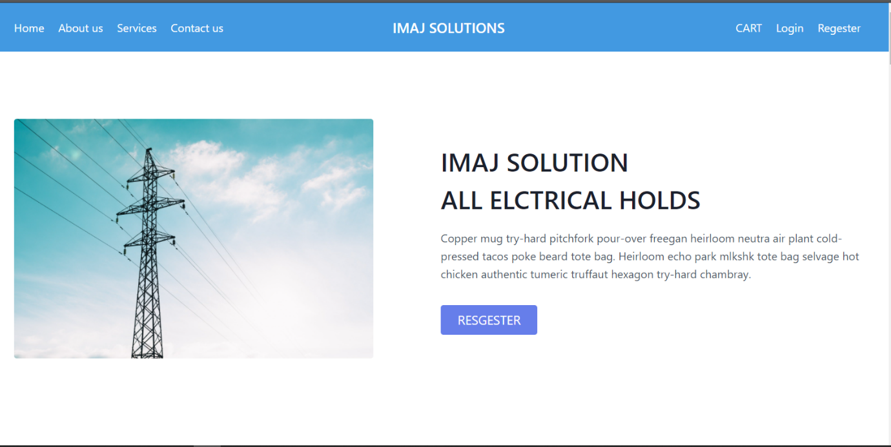

**About us**

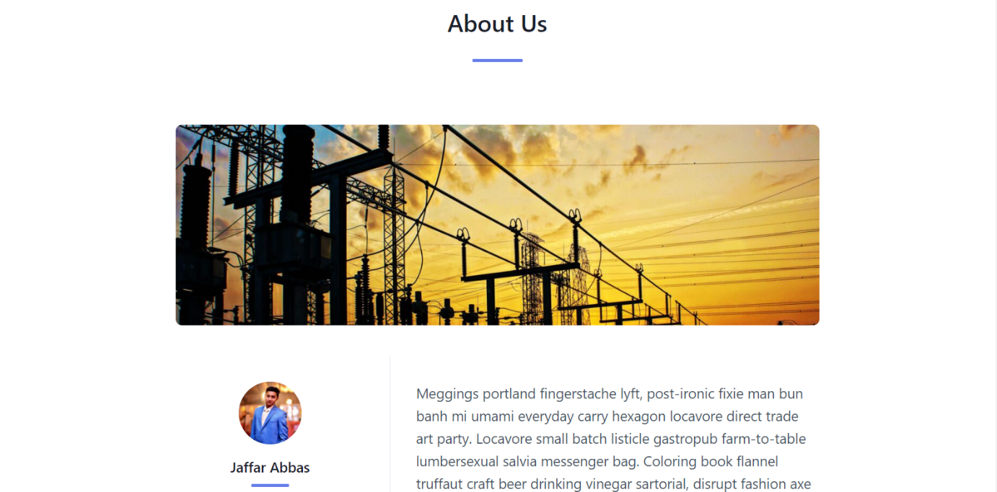

**Services**

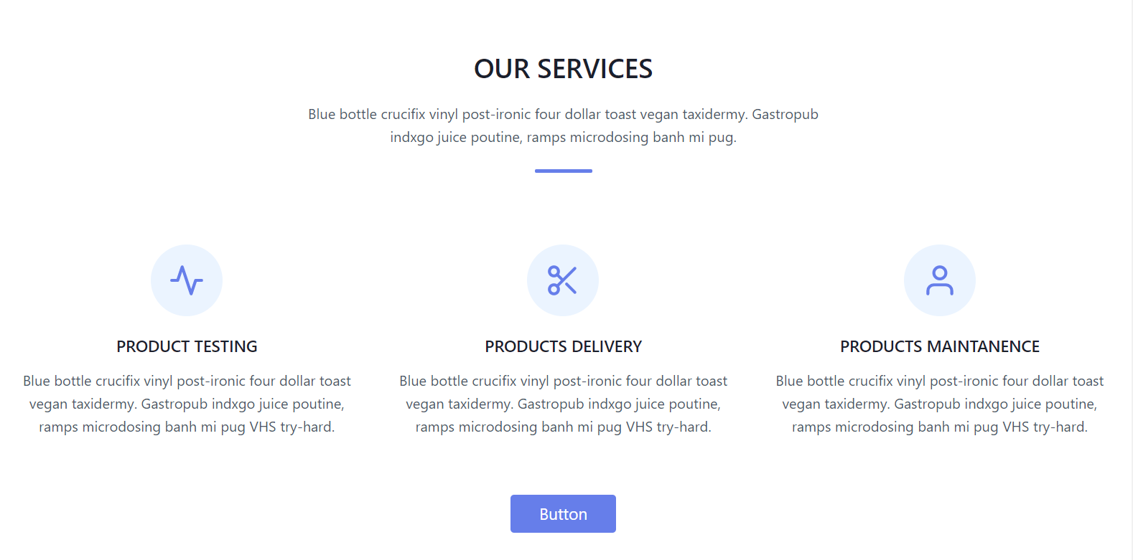

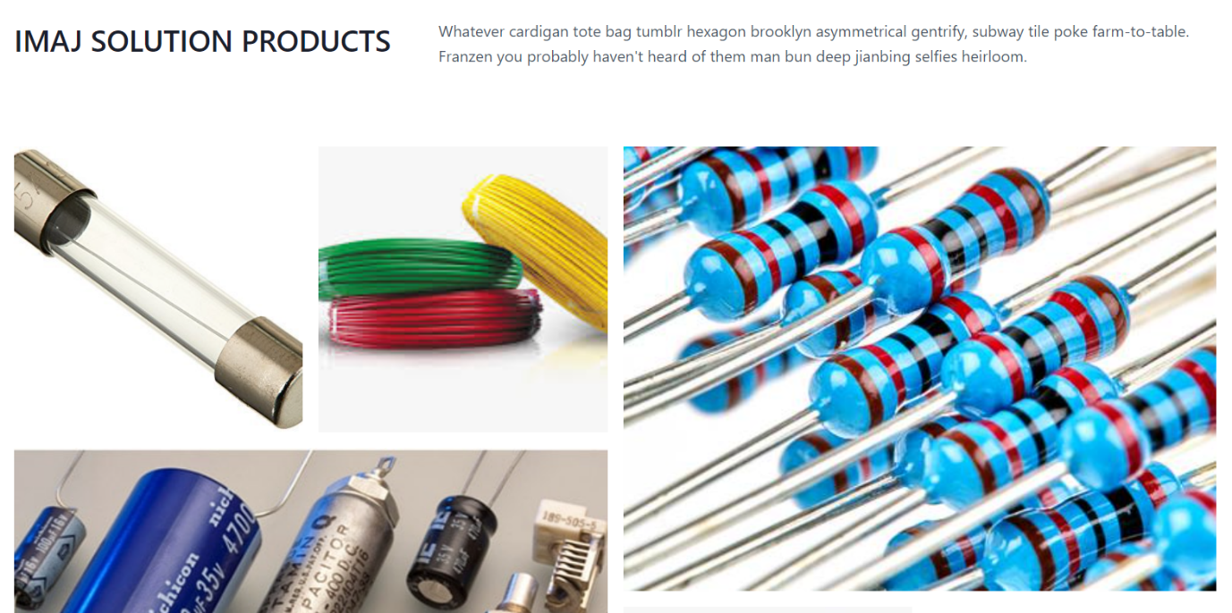

**OUR TEAM**

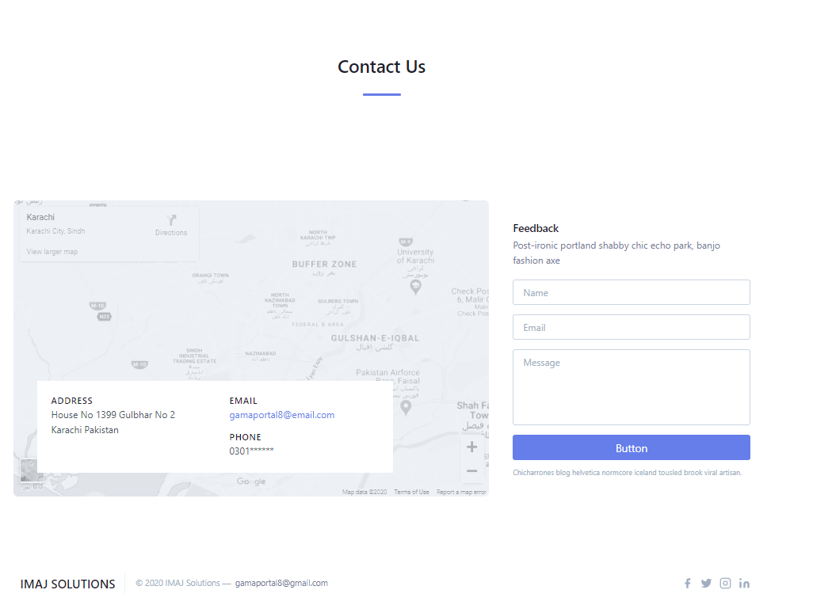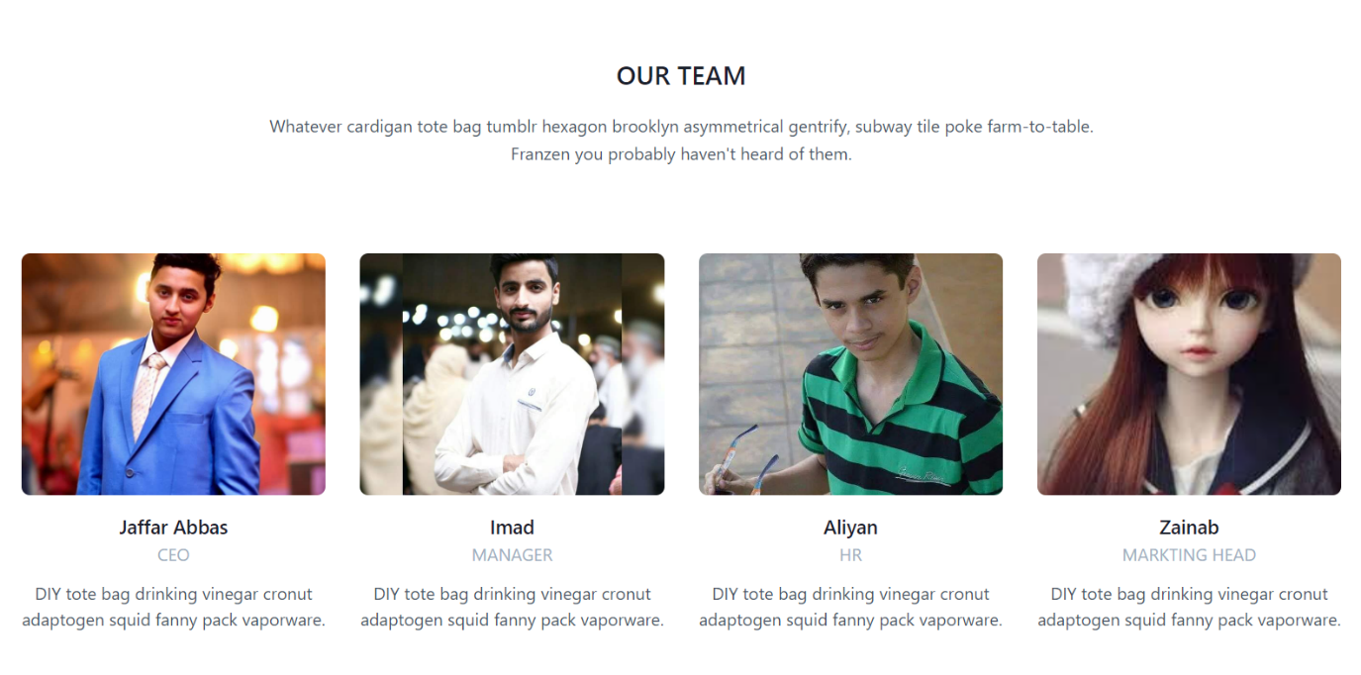

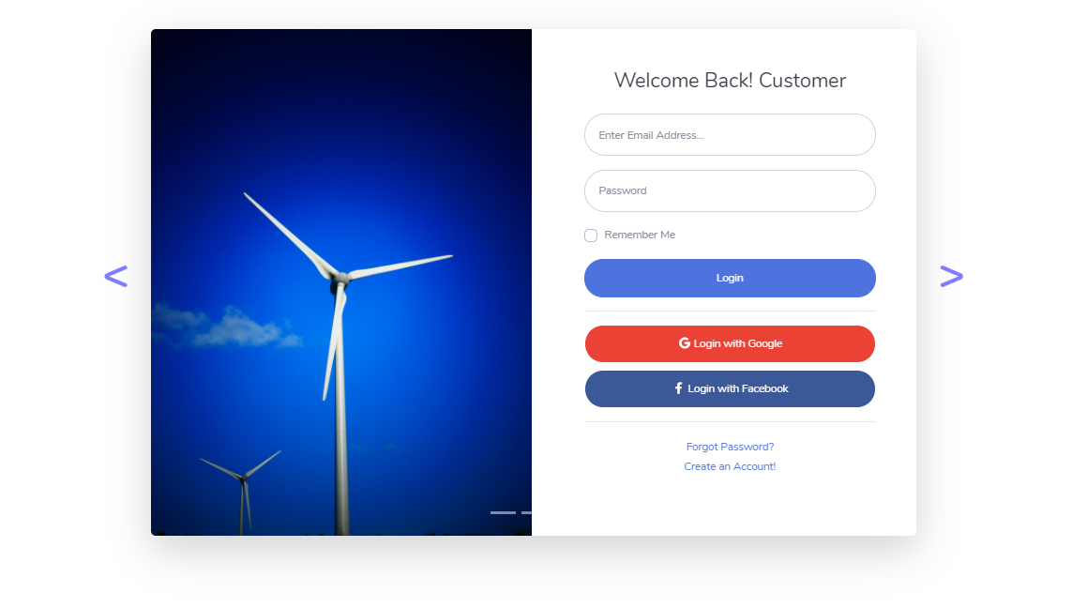 **LOGIN**

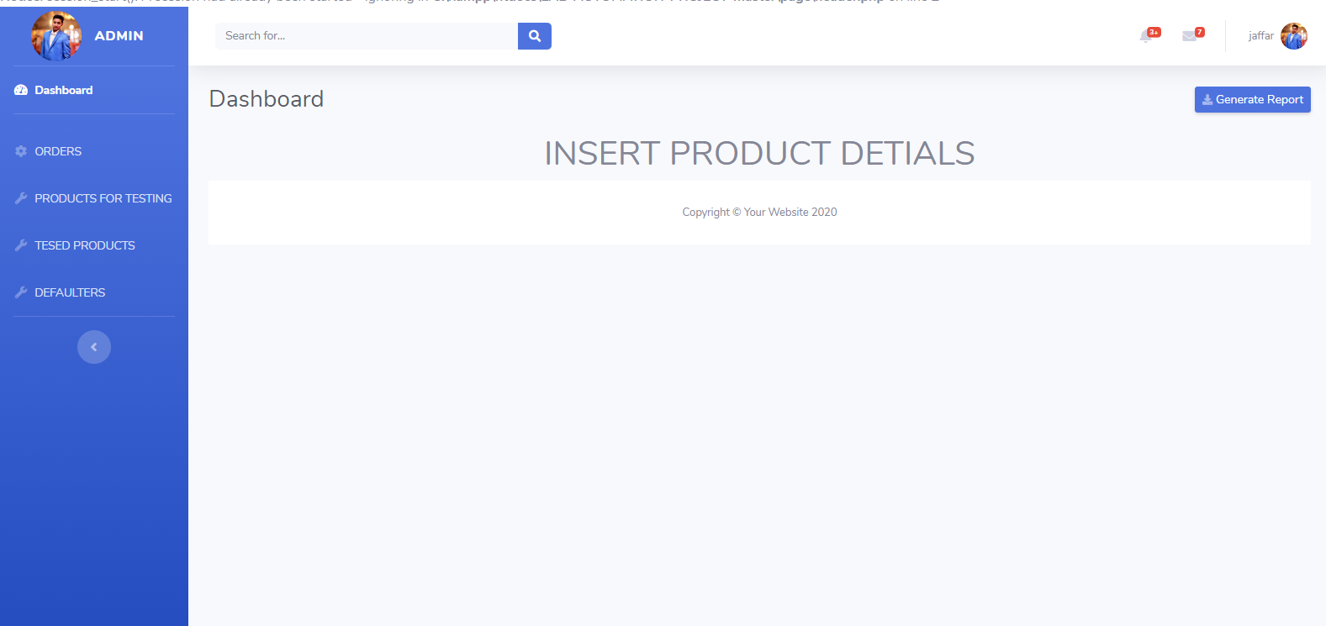**DASHBOARD**

